**CODE SNIPPETS**

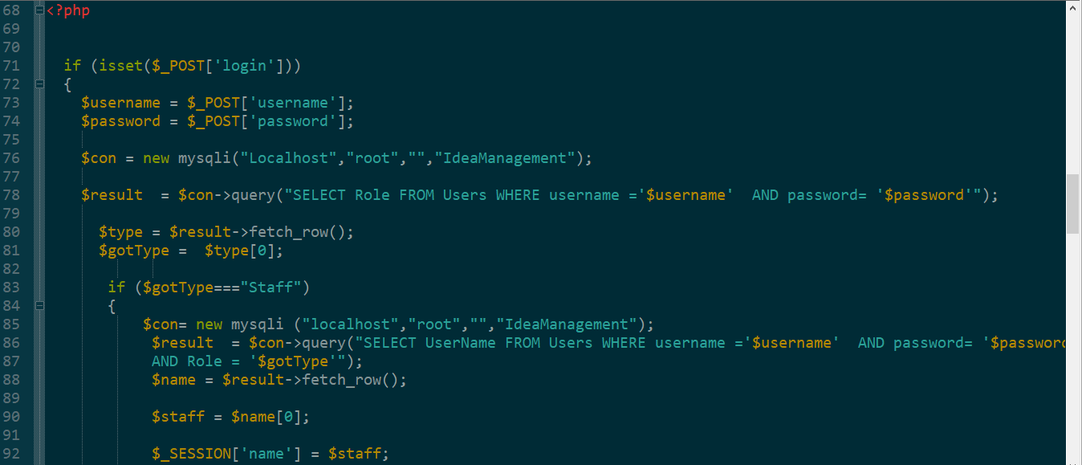

**LOGIN PAGE**

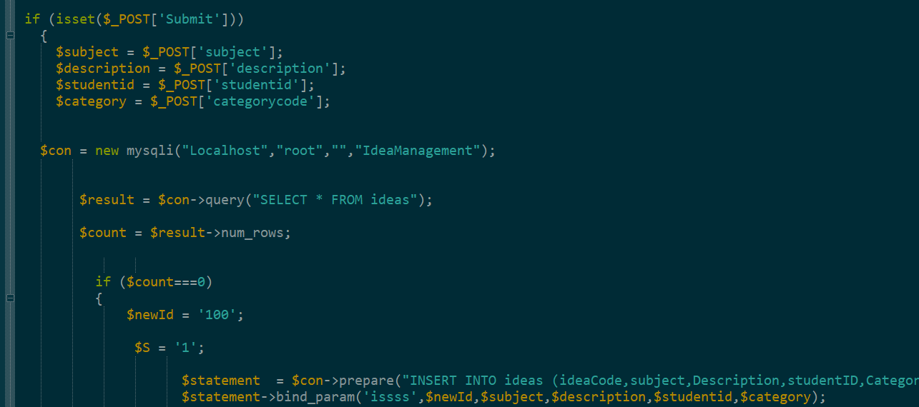

**POSTING IDEAS**

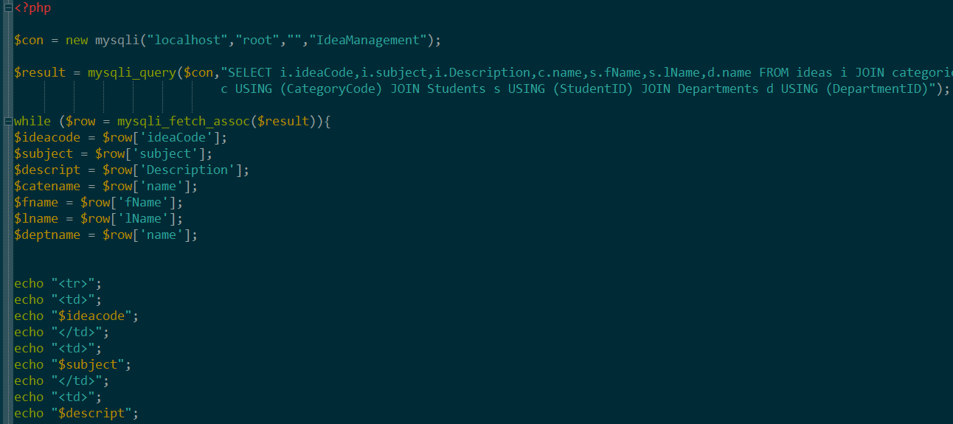

**VIEW POSTED IDEAS**

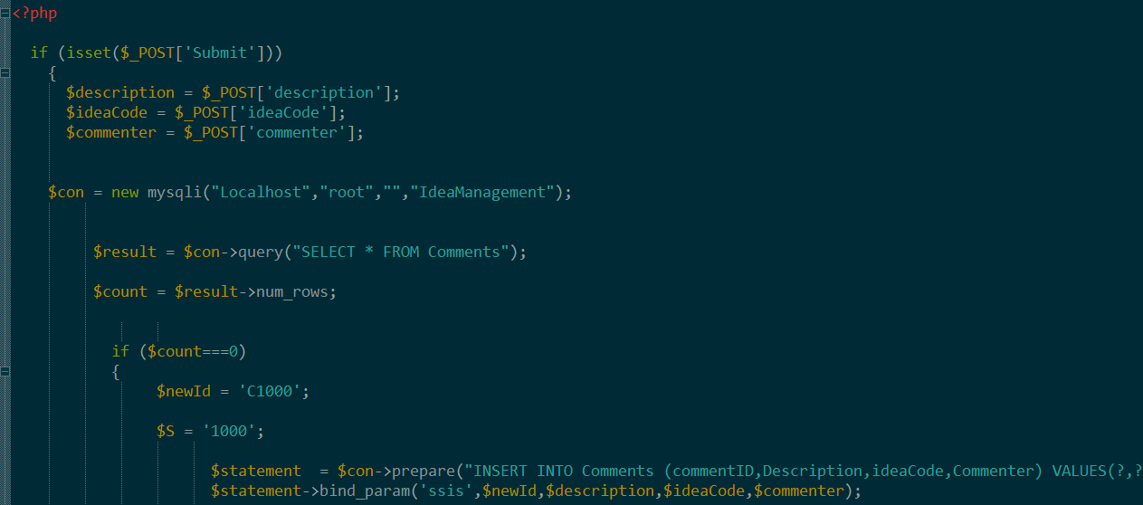

**COMMENTS SUBMISSION**

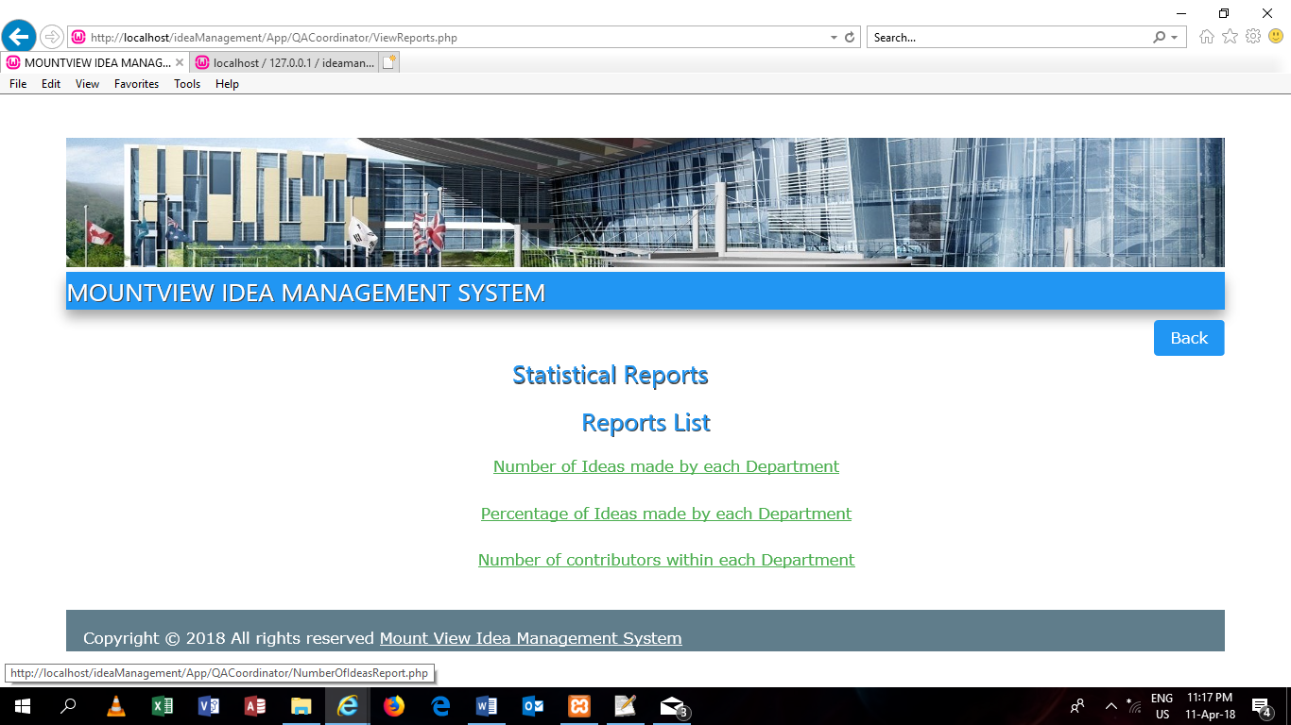

**REPORT LIST PAGE**

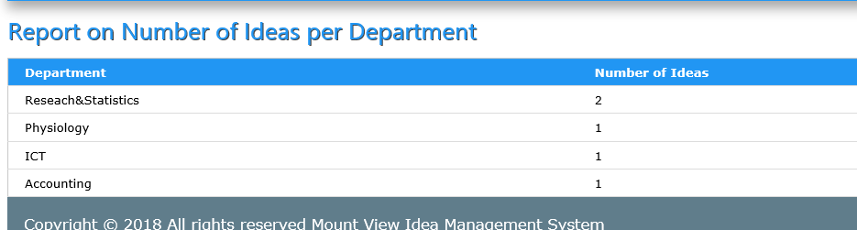

**REPORT ON NUMBER OF IDEAS BY EACH DEPARTMENT**

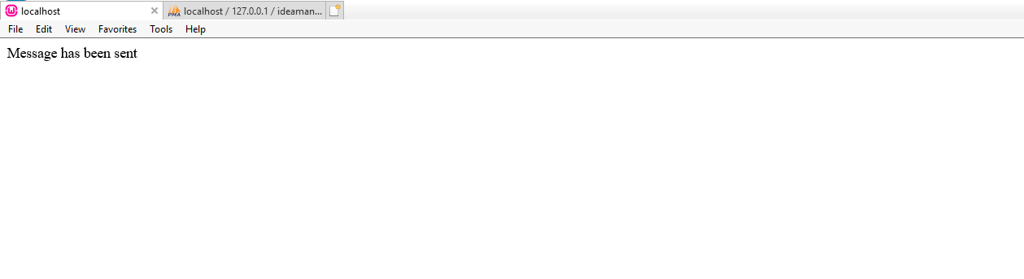

**Email Confirmation message**

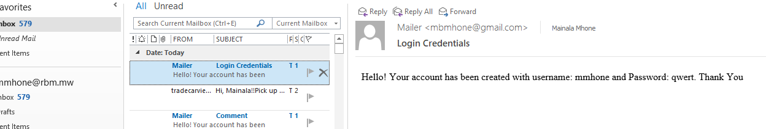

**Received Email in the user inbox**